# Shape

The main debate in deciding the shape of the base was between a square base and a circular base.

Circular Base

* Pros

The typical shape of a robotic vacuum cleaner is a disk. The reasons they are disk-shaped is because of mobility. They can maneuver through tight spaces and still clean effectively. When they bump into a wall or piece of furniture, since it is a circle, it can easily turn around and adjust its position and continue cleaning.

* Cons

The major problem with the vacuum being a circle is that it cannot clean the corners of rooms very well.

Square Base

* Pros

If you change the shape to a square, then the vacuum can get into the corners and clean better, but there are no square robot vacuums.

* Cons

As the vacuum is going along and cleaning it will bump into obstacles and then reposition itself. As the vacuum is re-positioning itself, the edges can come into contact with obstacles and will waste more time re-positioning itself instead of cleaning.

So considering the above facts to create a robot more applicable for the real life purposes a **Circular Base** robot was chosen for its **better maneuverability.**

# Wheel Placement and Driving System

The position of the wheels was considered by taking mainly two factors in mind.

1. To evenly distribute the load on the wheels system.
2. To accommodate large front sweeping brushes for better cleaning coverage.

A three wheel system was carefully and systematically laid out to ensure low center of gravity and accurate motion of the robot. The wheel placement was decided by triangulation method to provide more room at the front for a higher sweeping area for the brushes. Two dc motor controlled wheels were at the back and a front ball type caster wheel for support.

A and B are the points on the base circle. Here P is the midpoint of the line AB . It is the point where the wheel will be placed. Second back wheel will be placed at the point that is the mirror of P 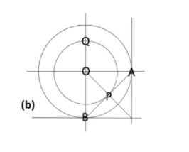about OB.

Q is the point where the front caster wheel is to be placed.

For the driving system, two individually controlled DC motors are used to provide desired rotational speed to each wheel. As a result the wheels can not only move forward but also turn by changing the speeds of the wheels.

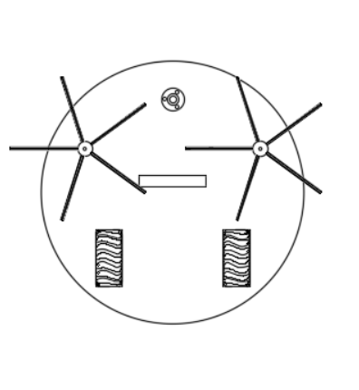

# Material and Component selection

## Body

The material being used for the case and most of the robot is ABS because it is easily

manufactured, cheap and it can be injection molded. Acrylonitrile butadiene styrene, or

ABS, is a common thermoplastic used to make light, rigid, molded products such as

pipes, golf club heads. The styrene gives the plastic a shiny, impervious surface. The

butadiene, a rubbery substance, provides resilience even at low temperatures. ABS can be

used between −25 °C and 60 °C.

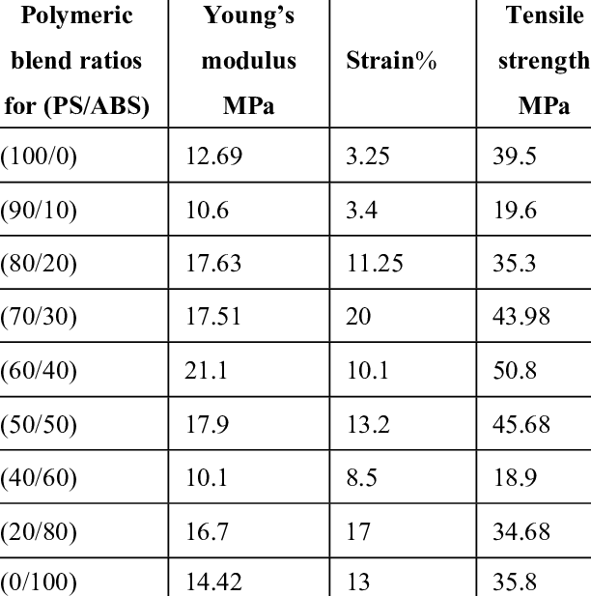

The outer case and the top are designed to be 5mm in thickness to provide a safe build and the base plate is kept to 10 mm in thickness to hold the weight. The weight of the internal components was around 2.5 kgs.

An approximate simulation for load design was done with an even distribution of 3 kgs over the base along with the outer case and the result gave a von Mises stress of 0.013 MPa.

So the base can handle a lot larger loads as compared to the one currently applied. Even half the thickness of the base can be sufficient for the load currently applied.

Currently the thickness is kept the same for need be arise for higher loads in the future

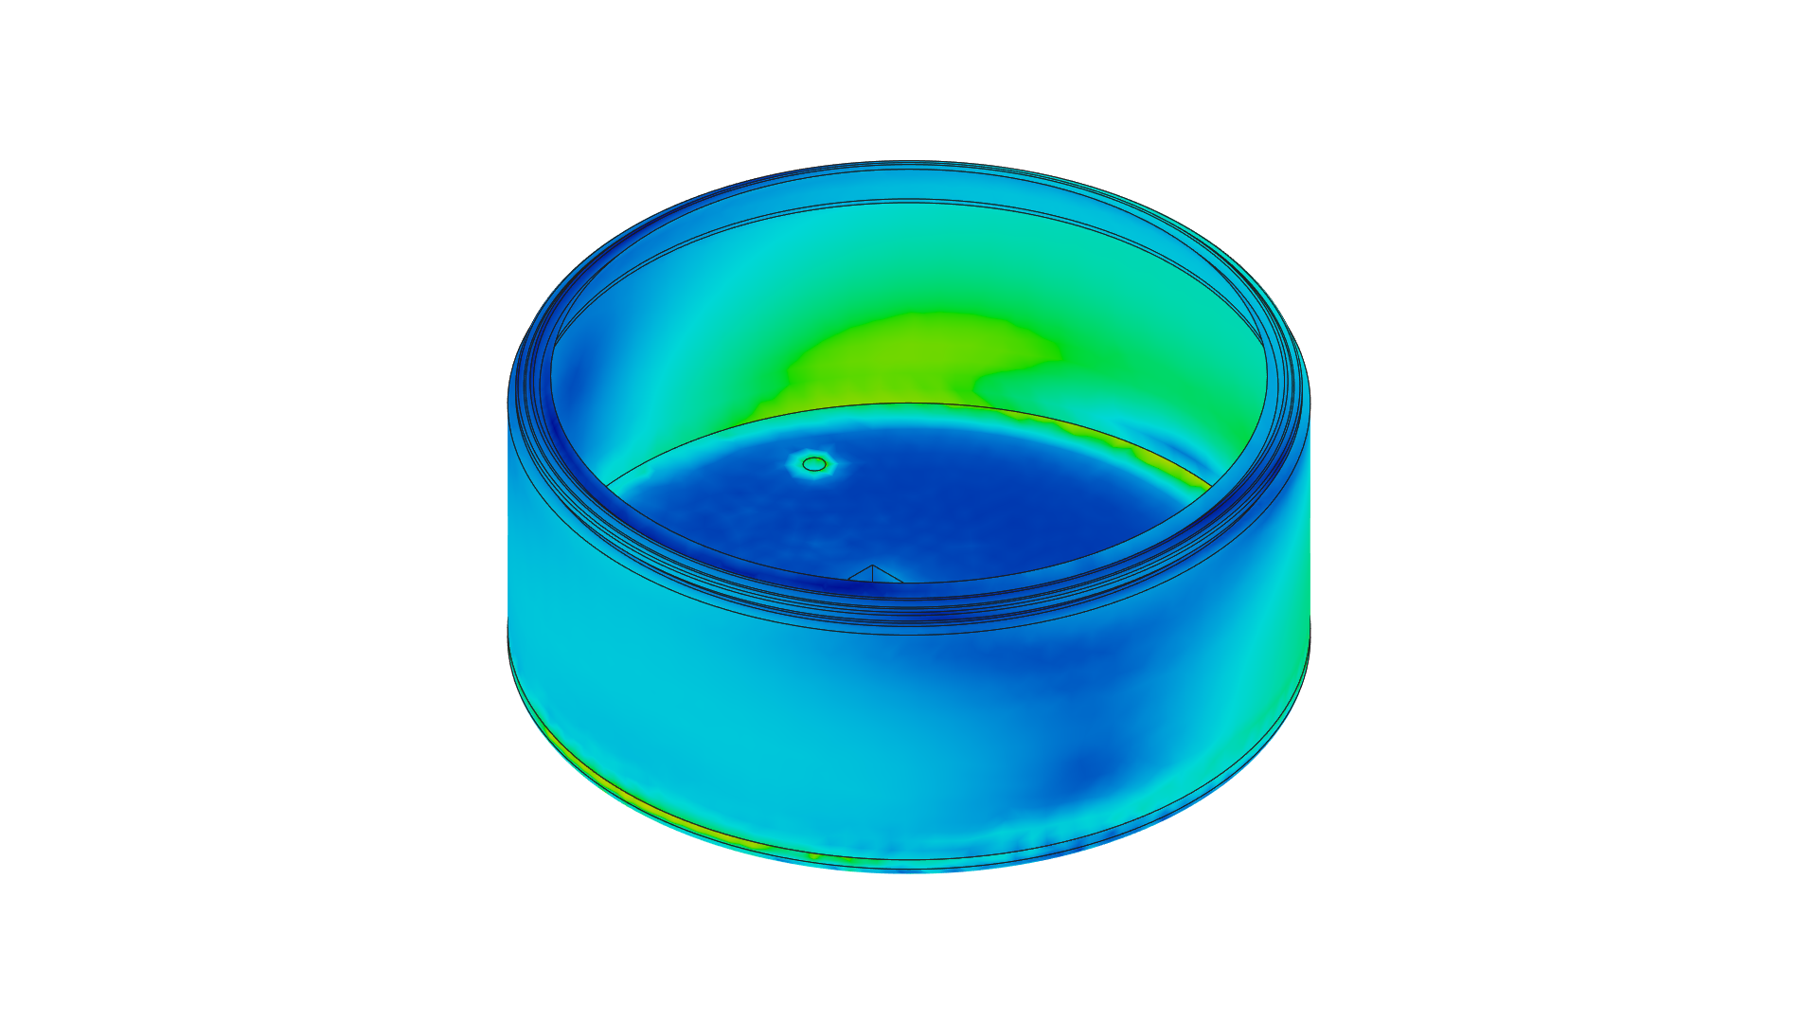

[MPa] 0.00001  0.01292

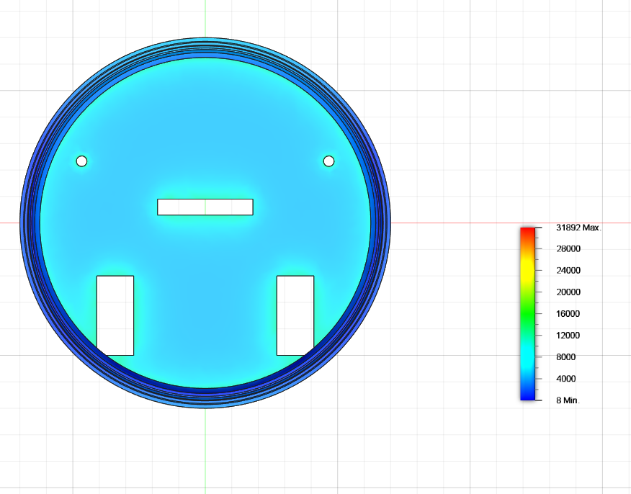

## Fan

The design uses a single impeller fan and has a small suction hole at the bottom of the base to provide sufficient vacuum power to suck the dirt. It at maximum capacity can have a flow rate of 3 m3/ hr.

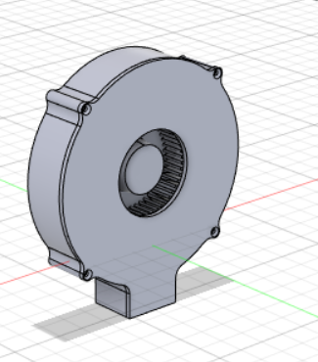

## Brushes

The brushes that will be used will be expected to rotate at 4500RPM . This transmitted

centrifugal force will translate to a lot of stress on the rod. But as shown above the base plate made of ABS has high strength to handle the stresses.

The brushes are arranged in a circular pattern to provide complete all around coverage. The radius of the brush is taken to be 100mm to provide efficient coverage.

The outer circle depicts the effective area that the brushes can clean.

The brushes used can be of nylon to provide necessary strength and flexibility.

## Bin

The bin to collect the dirt is also to be made of ABS for a sturdy build that does not wear with time. The bin has an internal volume of 712500 mm3 to hold the dirt.

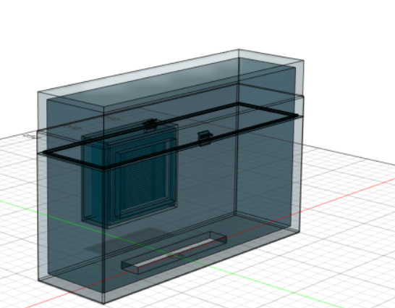

# Turning

The driving system as mentioned consists of 2 DC motors with individual differential control for adjusting the speed. The velocity value is specified in millimeters per second and describes the averaged velocity of the two drive wheels: ((Vleft + Vright)/2). From that equation you can see that a positive velocity makes the Roomba go forward and a negative velocity makes it go backward. But since this is an average and Roomba, like all real machines, takes time to come up to a speed and slow down from a speed, any command will result in positional error, and a series of commands with rapid starts and stops will accumulate position errors to an even greater degree. But for this project we will consider the motor to provide sufficient acceleration to make the time to reach max velocity negligible.

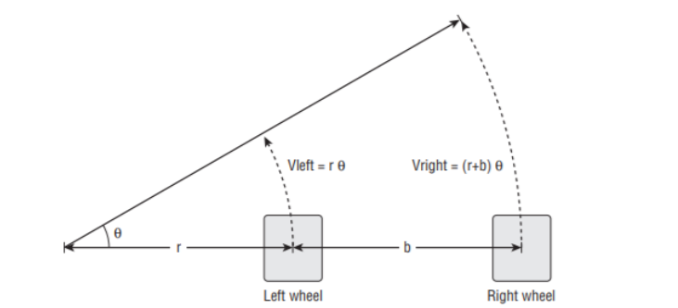Vleft = rθ

Vright = (r+b)θ

V = (Vleft + Vright) / 2

By eliminating theta we get

Vleft = V(1-b/2r)

Vright = V(1+b/2r)

So we can adjust the speeds of each wheel in accordance with the necessary type of the turn that we need the robot to make.

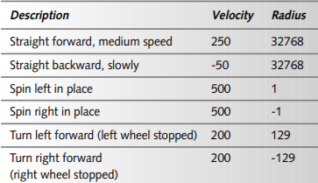This table provides some examples of how the above equation can be used to perform turning calculations.

## Slipping and Skidding

Skid and slip have been at large focus of researchers when considering the motion of the robot. The modern solution involves the placement of Rotary Incremental Motion Encoders to perform the task of monitoring and controlling the slip and skid. Shown below is the control process.

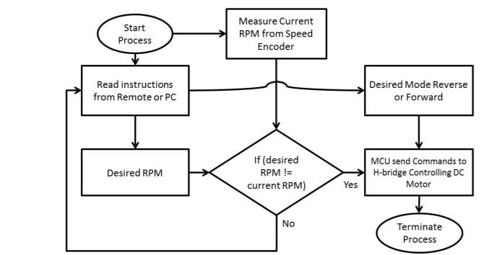

For our robot design we didn't have the resources to perform the above task. But the design and the geometric placement was done in such a way to 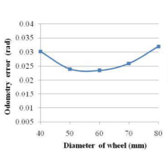minimize the above losses. The relation of slip with diameter is shown beside. As a result , considering the weight of the robot ( approximately 4 kgs) and the required speed a good diameter size was about 70 mm as used in the robot.

Even though the thickness of the wheel used by us is large and can increase slip, the larger thickness provides better grip at turning and the high powered motor used by us helps in negating the slip effect and helps in reducing the skid.

The wheel used is about 34 mm in thickness and 75 mm in diameter and has necessary threading to provide a good grip.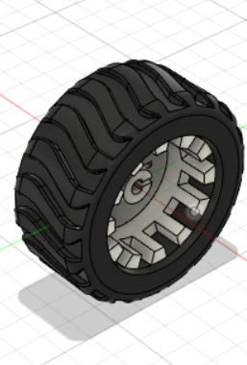

## 

# Cleaning Coverage

## Straight path

For all calculations a 0.5m X 0.5m unit cell is considered. The figure below shows the cleaning coverage of the robot on a straight path.

## 

## Turning Coverage

Turning Steps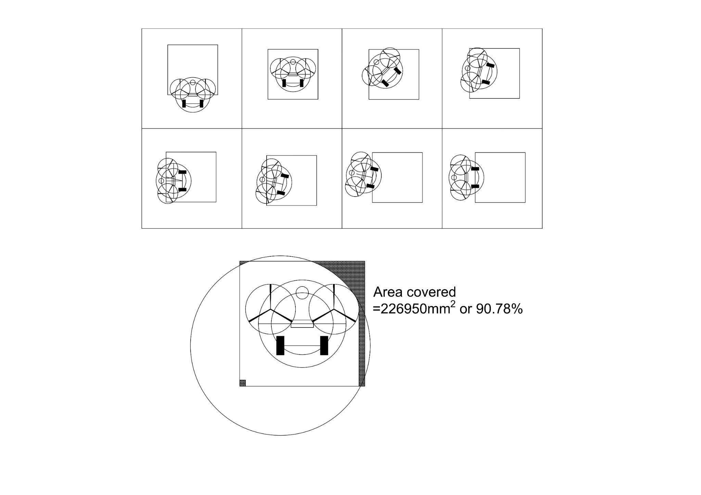

1. The robot continues on the straight path till its geometric center aligns with the center of the unit cell.
2. The robot performs a 90° swing turn about one of its wheels(in the direction of the turn).
3. The robot is now not aligned with the center of the edge that it is facing, so to get aligned it turns about the center of the wheel axis for 13°.
4. Then it moves straight for a 167.057 mm and now rotates in the opposite direction of initial 13° to realign the robot with the unit cell's edge.

# Cost considerations

| Component | Approximate price |
| --- | --- |
| Body (ABS) | 300 Rs (110 rs / kg) |
| Brush | 100 Rs ([nylon bristles cost](https://www.tradeindia.com/manufacturers/nylon-bristles.html) 340 rs/ 10 kg) |
| Wheel | 200 Rs (100 per wheel) |
| Fan | 100 Rs |

**Total = 700 Rs**

# Improvements

1. Better slip and skid control system
2. Can have a mopping function as well. The base plate has space on its sides to accommodate water tanks on both sides that can hold a combined 200 ml of water for cleaning purposes. The following design could not be added due to time constraints for design and power requirements of the pump.

